**Lab 3: Install and Configure WDS Server on Windows Server 2019**

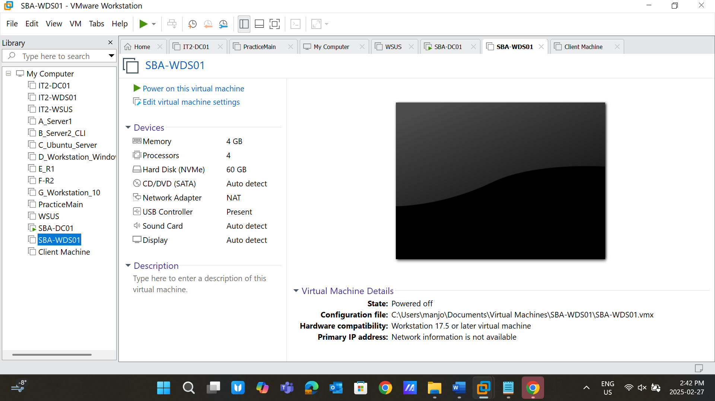

**Lab Objective:**

To install and configure Windows Deployment Services (WDS) on a Windows Server 2019 setup and deploy a Windows 10 or 11 operating system to a client machine.

**Lab Topology:**

**Main Web Server:**

* **Host Name**: IT2-DC01
* **Role**: Active Directory Services (AD DS), DNS, and DHCP
* **RAM**: 4 GB
* **Domain**: NORTHERNCOLLEGE.LOCAL

**WDS Server:**

* **Host Name**: IT2-WDS01
* **Role**: WDS Server, PXE Boot Server
* **RAM**: 4 GB
* **Domain**: NORTHERNCOLLEGE.LOCAL

**Client Machine:**

* Physical or virtual machine with no operating system
* Network boot-enabled machine
* **RAM**: 4 GB

**Lab Instructions:**

**Prerequisites:**

1. Ensure that **Lab 1** and **Lab 2** are complete.
2. Verify that the domain **NORTHERNCOLLEGE.LOCAL** is functional, and IT2-DC01 is properly configured as a Domain Controller (DC).

**Step-by-Step Instructions:**

**Step 1: Verify Hardware Configuration**

* Open the system properties of IT2-WDS01.
* **Screenshot 1**: Take a screenshot of the hardware configuration. A screenshot of a computer

  Description automatically generated

**Step 2: Configure IPv4 Settings**

* Configure the IPv4 settings for IT2-WDS01 as required.
* **Screenshot 2**: Capture the IPv4 configuration settings. A computer screen with a black screen

  Description automatically generated A computer screen shot of a computer screen

  Description automatically generated

**Step 3: Change the Computer Name and Join the Domain**

* Change the computer name to **IT2-WDS01**.
* Join the computer to the domain **NORTHERNCOLLEGE.LOCAL**.
* **Screenshot 3**: Capture the screen showing IT2-WDS01 as a member of the domain. A computer screen shot of a computer

  Description automatically generated A computer screen shot of a computer

  Description automatically generated

**Step 4: Organize IT2-WDS01 in AD DS**

* Move the IT2-WDS01 computer account to the **Server folder** under the **CANADA directory** in Active Directory.
* **Screenshot 4**: Capture the screen showing the new location of IT2-WDS01. A computer screen with a black screen

  Description automatically generated

**Step 5: Create a Volume for WDS**

* Shrink a partition by **25 GB** to create a new volume.
* Label the new volume as **WDS**.
* **Screenshot 5**: Capture the disk management screen showing the new volume. A computer screen shot of a computer

  Description automatically generated

**Step 6: Install Windows Deployment Services**

* Open the **Add Roles and Features Wizard**.
* Select **Windows Deployment Services** and complete the installation process.
* **Screenshot 6**: Capture the results page after the installation is complete. A computer screen with a black screen

  Description automatically generated

**Step 7: Configure Boot Options**

* Configure the PXE Boot options and set the bootable name as **boot\x64\** A computer screen shot of a computer

  Description automatically generated
* **Screenshot 7**: Capture the PXE boot settings showing the bootable name. A computer screen shot of a computer

  Description automatically generated

**Step 8: Configure WDS Path**

* During the WDS configuration, set the path to the previously created **WDS volume**.
* **Screenshot 8**: Capture the screen showing the configured path. A computer screen shot of a computer

  Description automatically generated

**Step 9: Configure PXE Server Initial Settings**

* In the PXE Server Initial Settings, select the option **Respond to all client computers (known and unknown)**.
* **Screenshot 9**: Capture the PXE Server Initial Settings page. A computer screen with a black screen

  Description automatically generated

**Step 10: Add an Image**

* Use the **Add Image Wizard** to create an image named **Win10-Image**.
* **Screenshot 10**: Capture the screen showing the created image. A computer screen shot of a computer

  Description automatically generated A computer screen shot of a computer

  Description automatically generated

**Step 11: PXE Boot the Client Machine**

* Boot the client machine over the network using PXE.
* **Screenshot 11**: Capture the WDS Boot Manager screen showing the client IP, server IP, and server name. A screenshot of a computer

  Description automatically generated

**Step 12: Complete Installation on Client Machine**

* Install Windows 10 or 11 on the client machine.
* After installation, run **whoami** and **ipconfig** commands.
* **Screenshot 12**: Capture the outputs of **whoami** and **ipconfig** on the client machine. A computer screen shot of a black screen

  Description automatically generated